**User Interaction Requirements:**

**Functional requirements:**

1. After the user left-clicked an interactable object and no other object is selected the system must report this action and an object id to the GameLogic component.
2. After the user left-clicked an interactable and collectable object the and no other object is selected system must add this item to an inventory list and remove it from the game view.
3. After the user left-clicked an interactable object that is placed in the inventory the system must report this action and an object id to the GameLogic component
4. After the user left-clicked and interactable object that is placed in the inventory the system must make the item follow the mouse cursor.
5. After an interactable was added to the inventory the system must make the interactable object render with a specially assigned inventory
6. After the „i“ button was pressed by the used the system must display an inventory view and add all interactable items to it.
7. After the user left-clicked and interactable object that is placed in the inventory the system must save this item as selected item
8. After an item of the inventory was selected and the user presses the right mouse button the system must unselect the item.
9. After an item of the inventory was selected and the user presses the right mouse button the system make the previously selected item no longer follow the mouse.
10. After an item of the inventory was selected and the user presses the left mouse button on another interactable object the system must make the previously selected item no longer follow the mouse.
11. After an item of the inventory was selected and the user presses the left mouse button on another interactable object the system must must unselect the item.
12. After an item of the inventory was selected and the user presses the left mouse button on another interactable object the system must report this action, the selected object’s id and the clicked objects id to the GameLogic.
13. The system must allow the GameLogic to instanciate an interactable object in either in the inventory view or the game   
    view.
14. The system must allow the GameLogic to change (to be specified) attributes of an interactable game object.

**Design**

An interactable object is modeled by the Interactable class. Objects of these class are stored by an InteractableManger object. Interactable

objects report to this class if they were left-clicked. Interactables have currently the following attributes

* isCollectable: indicates whether an object can be put in the inventory
* isInInventory: indicates whether an object is in the inventory
* isActive: indicates whether an object is currently part of the game
* id: an id to reference objects outside the component

The InteractableManager manages all interactable objects and is the interface to the component. It is also responsible for adding and removing the interactables to the scene according to their states (e.g. if an interactable is in „isInInventory“ state it is added if the inventory is opened). If an interactable was clicked the manager adds it to the inventory if it isCollectable is true. If the inventory was opened and an interactable of the inventory was clicked the manager saves it as being selected and takes care that it follows the mouses cursor. If an interactable was clicked the manager reports the ids of the clicked interactable and the selected interactable to an game logic component. The manager also provides (restricted) manipulation functionality for the

interactables to the game logic component.

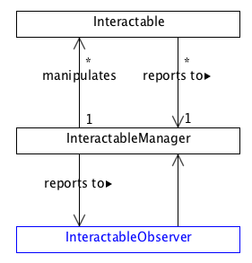

**Things to consider:**

* Chose fixed (mb better) camera size
* Make placing of objects more generic so that different monitor ratios/resolutions are supported
* Item following the cursor doesnt look 100% right at the moment.